Lee Copen Workshop
Material List: suggested supplies

100% cotton Cold Press Watercolor Paper 150 lbs, Arches or Blick Premier. Either buy a block about 11x14 or a couple of sheets that can cut into 4 pieces and a board onto which you can attach the paper
Professional quality Watercolor paint in tubes(and a palette) or pans. I use cobalt blue, ceruleum blue, ultra marine blue, payne's gray, violet, alizarin crimson, sap green, hookers green or viridian, lemon yellow, cadmium yellow, cadmium red, yellow (or gold) ochre, raw sienna, and burnt umber. Artists can bring what they have, I am not too fussy about colors.

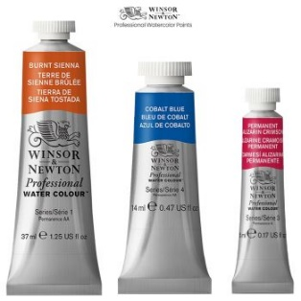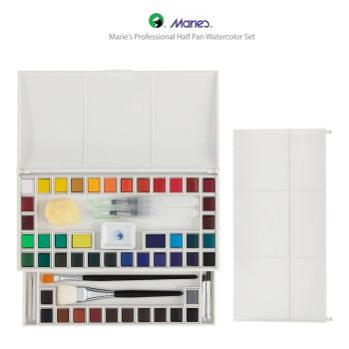

Brushes: a selection of quality watercolor brushes, with at least one big (2”) flat. I often only use 2 brushes: a big flat, and a medium round that comes to a nice point, so you don’t need too many brushes, bring what you have.
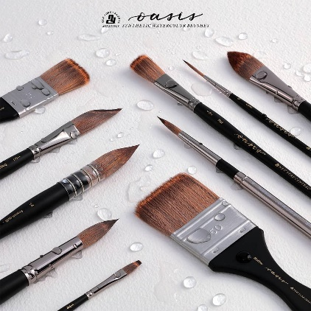

Also a pencil, eraser, masking tape, a sponge, paper towels, a water container and a sketchbook.

